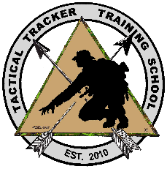
Vehicle and Foot Surveillance for Law Enforcement:
Tactical Tracker Training School LLC
Vehicle and Foot Surveillance for Law Enforcement
When: 13-17 June 2022 (5 days, 50 hrs) Rowan-Cabarrus Community College

The Vehicle and Foot Surveillance for Law Enforcement course is designed to introduce and train individuals to function as a competent and discreet surveillance operator while training the individuals to properly function in a surveillance team setting to achieve maximum efficiency and results without alerting the suspect that they are being observed. The course trains the surveillance team members to operate in vehicles or on foot, as well as conducting multi-mode follows which include the possibility of transitioning from foot, vehicle, and/or public transportation during a single follow.

Prerequisites: Sworn Law Enforcement, municipality, county, state, or federal agencies.
Attire: Students are encouraged to wear street clothing day 1 (after lunch), and for the entire day from days 2-5. Blending into the general public is an important part of conducting surveillance. Changes of clothes (shirts, hats, wigs) are also encouraged.
Required Equipment: Rental Vehicle or Unmarked civilian looking vehicle, Vehicle GPS and mount, cell phone, note taking materials, civilian backpack (non-tactical), wired or Bluetooth headphones/earbuds. Comfortable footwear
Recommended Equipment: binoculars or monocular (8x42 is ideal), tablet or iPad, camera,
Rowan-Cabarrus Community College 1333 Jake Alexander Blvd S. Salisbury, NC
Building N110 – Room 112
Click here to register or visit the RCCC website at www.rccc.edu/lawenforcement/training-calendar.
.
TTTS: Larry Wilkinson tacticaltracker@gmail.com 919 524-1685
www.TacticalTrackerTraining.com

